PART TWO

§ 1. Compton Effect

When a monochromatic beam of X-ray is scattered by a loosely bound electron, the scattered radiation in a particular direction contains two components, one having a lower frequency or longer wavelength called modified radiation and other having same frequency or same wavelength as that of the incident radiation called unmodified radiation . This effect of scattering of radiation is known as Compton effect.
The difference between the wavelengths of the modified and unmodified radiation is called Compton shift.
The angle between the direction of incident and scattered radiation is called `scattering angle'.

§ 2. Experimental arrangement of compton shift
Compton Effect can be studied using experimental arrangement as shown in following fig.
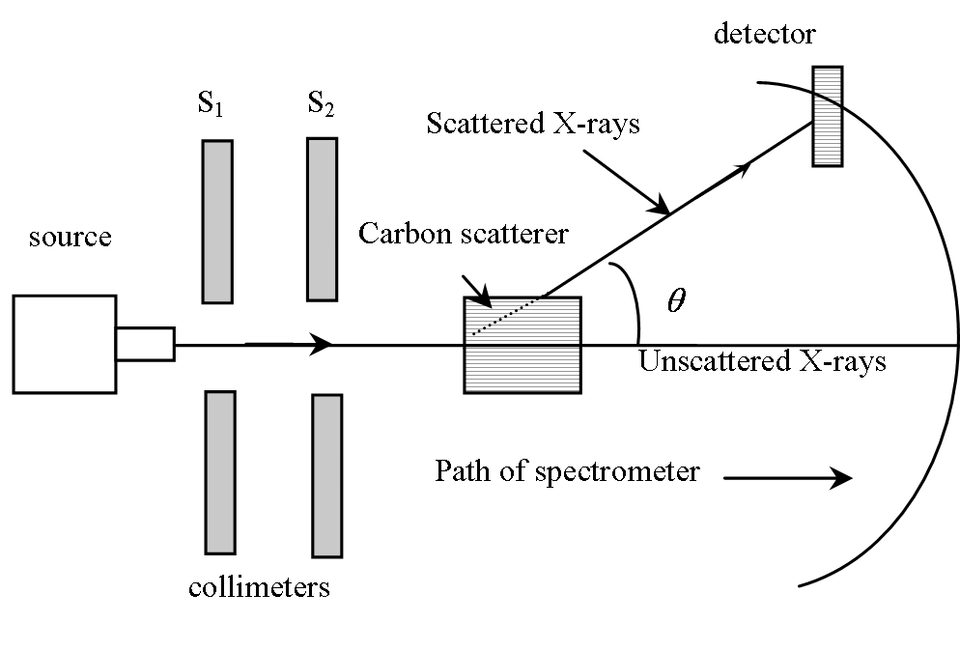
Figure : Experimental setup for compton effect

Collimated, monochromatic X-ray beam after passing through 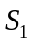 and 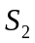 is allowed to fall on carbon scatterer `C'.
- Carbon block scatters X-rays in different directions.
- The intensity and wavelength of X- rays scattered through different angles were measured fig. shown below. Following graphs show that these peak to peak distance 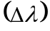is found to be greater at higher scattering angles.
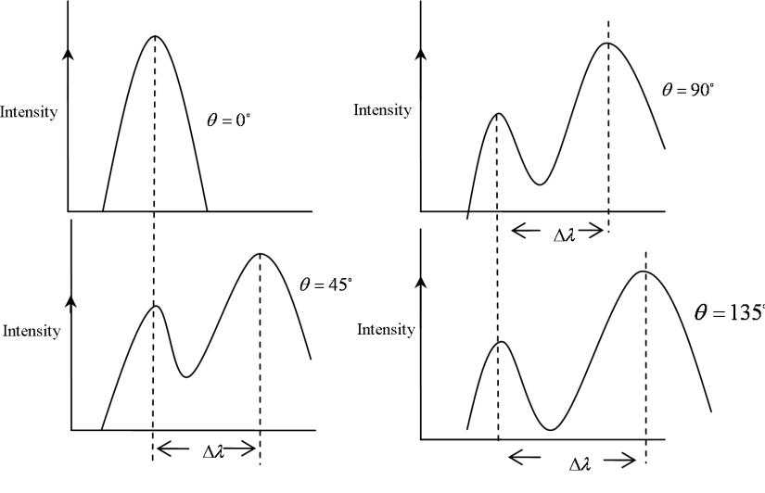
Figure : Experimental result of compton effect
Results
For each value of there are distinct intensity peaks.
- One peak corresponding to the wavelength same as the wavelength of incident wavelength and another with higher value of wavelength.
- This change of wavelength i.e., Compton shift increases with .

§ 3. Calculation of compton shift
In Compton effect,
- Compton consider the Einstein quantum theory of radiation. The X-ray of frequency ‘ν’ consists of large number of photons with energy hν and momentum 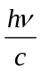.
- The collision between the high energy X-ray photon and electron is elastic and relativistic. The energy and momentum carried by scattered X-ray photon and recoil electron is governed by the laws of energy and momentum respectively.

§ 3.1 When X-ray is scattered by a loosely bound electron of the light element

The electron in the scattering block is assumed to be free and stationary. Because the energy of the electron (∼ 10 eV) is very small as compared to the energy of the incident X-ray photon (∼ 10-50 KeV). Thus,
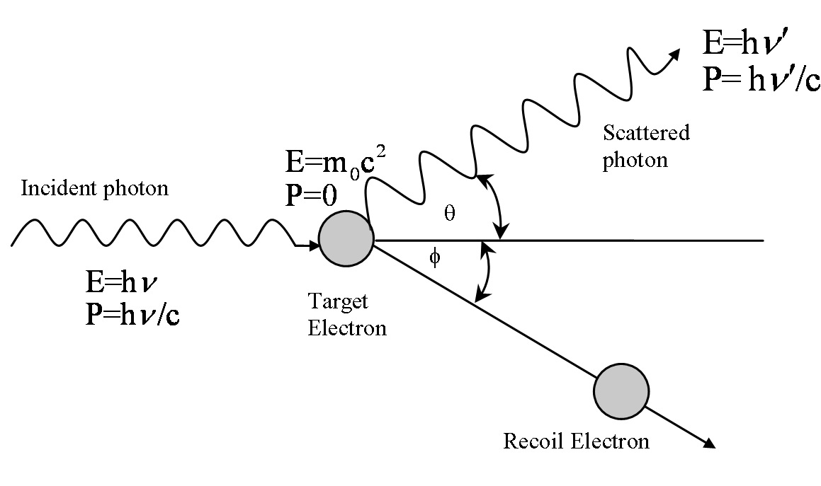
E=mc²
P=mv

According to the law of conservation of energy we can write 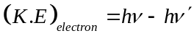…(1)
According to the law of conservation of momentum we can proceed as follows.
Taking momentum along horizontal 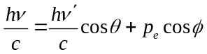
or, 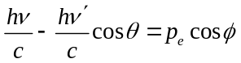 …….(2)
again along vertical direction 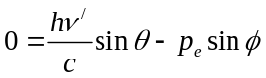
or, 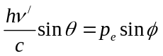 ……..(3)
Squaring and adding of (2) and (3) we have 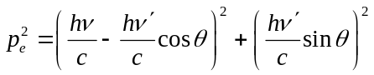
Or, 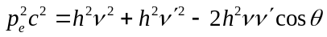 ..……(4)
From the expression of relativistic energy of electron we have
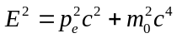 or, 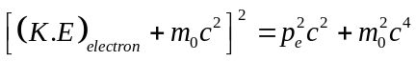
Putting the value of 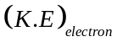from (1) we have 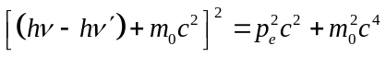
Or,
Or, 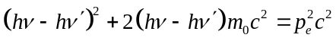 …………(5)
Equating (4) and (5) we have
Or, 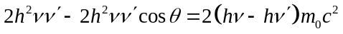
or, 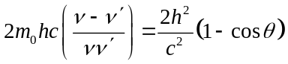
or, 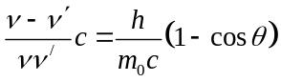
or, 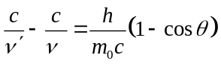
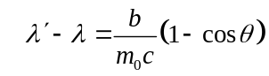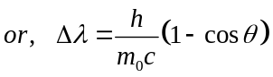

This is the expression for Compton shift.
Here 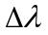 is the change in wave length of the incident radiation and it is called as compton's shift.
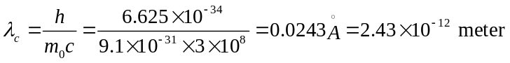
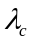is a constant which is known as Compton wavelength

§ 3.1.1 Observation from compton shift
- Compton shift is independent of the wavelength of incident radiation
- Wavelength shift increases with the angle of scattering and it reaches its maximum at 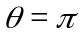
- For 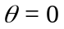; shift i.e., 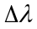=0 (minimum shift), we get one peak that means we are getting an unmodified radiation
- For 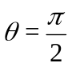; shift i.e., =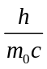
- For 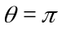; shift i.e., =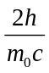(maximum shift)
Comparing (4) and (5) of the above one can understand that as increases increases. So we are getting one peak which is different from the incident radiation peak that means we are getting modified line.

§ 3.2 When X-ray is scattered by a tightly bound electron or the atom of the light element
If photon collides with a tightly bound electron or the atom of the element, the electron is not detach from the atom because the energy of the electron is comparible to the energy of the incident X-ray photon. So, the whole atom is involved in the collision process and mass of the electron 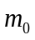 in the equation 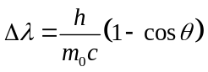is replaced by M, mass of the atom which is several thousand times greater than the mass of electron.
For carbon scatterer 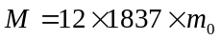 . Now 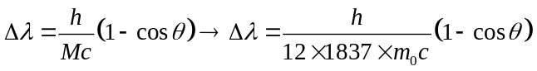
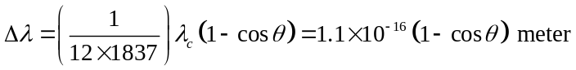
As compared to the Compton wavelength, this is 10⁻⁴ times.
Such a small change in wavelength cannot be resolved by Bragg’s spectrometer and hence such photons are recorded without change of wavelength for all values of angle of scatterening. This explains the presence of unmodified component of X-ray in the study of Compton effect.

Thus when collision of photon takes place with free electron this gives rise to modified radiation and when it collides with bound electron this gives rise to unmodified radiation.
In case of low atomic number elements the number of electrons in them is less and almost all electrons are loosely bound to the nucleus and are considered as free electron. Hence, when radiation is incident on these materials, there is collision between photon and free electron giving rise to modified radiation.
But in case of heavy elements number of electrons is more hence the number of tightly bound electrons is more as compare to loosely bound electrons. Photon collides with these bound electrons give rise to unmodified radiation.
Hence modified component of radiation is more intense in lower atomic number material whereas unmodified component is more intense in higher atomic number materials.

§ 4. Failure of classical theory to explain compton shift
According to classical theory, radiation is considered as electromagnetic waves. When energy is incident on scattering material, electrons of the material oscillate at the same frequency of incident radiation and an ocsillating charge particle (electron) radiates electromagnetic radiation uniformly in all direction with frequency as that of the frequency of incident radiation. Thus classically an electron should radiate uniformly in all directions and scattering radiation should not depend on `'.
Thus classical theory fails to explain existence of the modified wavelength and dependence of Compton shift on the scattering angle.

§ 5. Direction of the recoil electron
When radiation of frequency is incident on scattering material, scattered radiation consisting of modified and unmodified radiation is obtained and electron undergoes recoil.
Let be the angle between direction of recoil electron with the direction of incident radiation.
be the angle between scattered photon and direction of incident radiation.
If we apply law of conservation of momentum to this collision along and perpendicular direction we get,
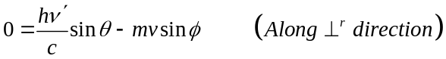
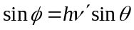 …(21)
and 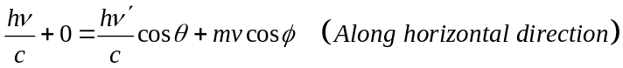
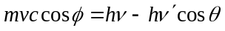 …(22)
Dividing (21) by (22), we get,
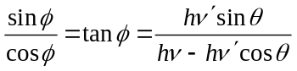
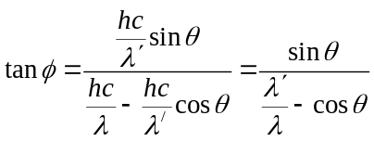
Or, 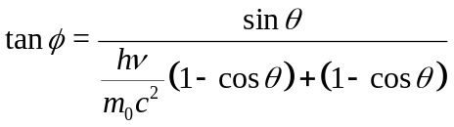
Or, 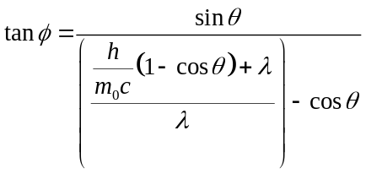
Or, 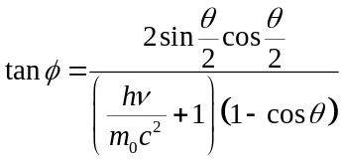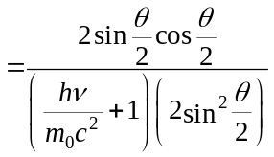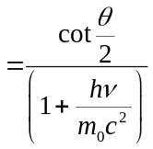
Thus,

Note:
When =0 so that 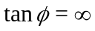 i.e. 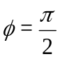
When = so that 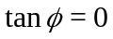 i.e. 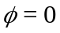
This is the maximum value of the angle at which recoil electrons are ejected.

§ 6. Kinetic Energy of the recoil electron interms of scattering angle
Kinetic energy of recoil electron is given by
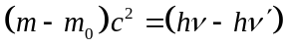
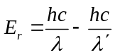
where 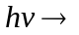Energy of incident photon.
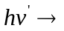 Energy of scattered photon.
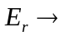Kinetic energy of the electron
So, 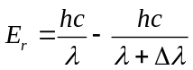 where is the Compton shift
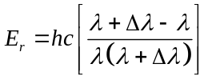
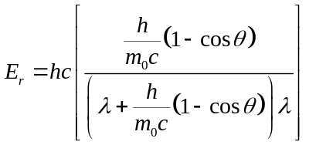
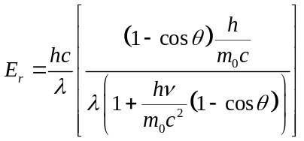
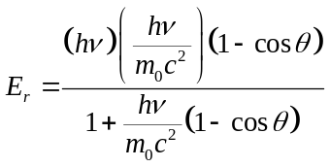
Hence 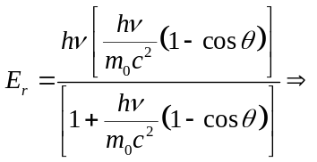 K.E for recoil electron in terms of scattering angle.

Note:
Compton effect cannot be observed with visible light but can be observed due to X-rays
Let us consider a visible light has a wavelength of 5000 Å. Then energy of that visible light can be estimated out as
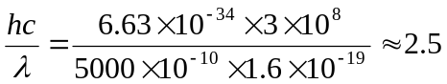eV
The binding energy of an electron inside an atom is more than 10eV. So when visible light will fall on a target, it cannot liberate electrons of the scatterer. Whereas the energy of a x-ray beam or gamma ray is well above 10eV which can easily liberate electron from a metal surface. So we cannot observe Compton effect with visible light.

§ 7. Pair production
Pair production is a phenomenon of nature where energy is converted to mass. It provides a conceptual framework for how our internal world gets translated into the physical reality we experience. The phenomenon of pair production can be view two different ways. One way is as a particle and antiparticle and the other is as a particle and a hole.
In this phenomenon a wave of energy or a photon (a packet of energy) interacts with a heavy nucleus to form an electron - positron pair. Pair production is observed to occur in nature when a photon or an energy wave packet, of greater than 1.02 million electron volts passes near the electric field of a large atom such as lead, uranium or other heavy material with a large number of protons (around an atomic number of 80 or 90).
In the pair production process, as diagramed in the figure below labeled “Pair Production - Energy Conversion to Mass,” the photon is literally split into an electron and its anti-particle, called a positron.
No conservation principles are violated when an electron-positron pair is created near an atomic nucleus. The sum of the charges of the electron (-e) and of the positron (+e) is zero, as is the charge of the photon.
Both have a rest mass energy equivalent of 0.511 million electron volts. Pair production requires photon energy of at least 1.02 MeV.

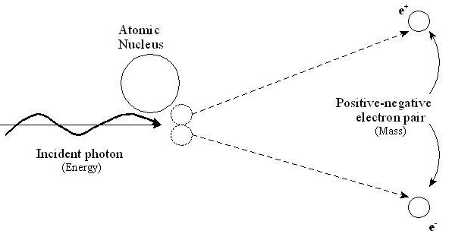
If the original packet of energy is greater than 1.02 million electron volts, any energy above 1.02 million electron volts is split between the kinetic energy of motion of the two particles. The corresponding maximum photon wavelength is 1.2 pm (electromagnetic waves with such wavelength is called gamma rays). The nucleus absorbs only a negligible fraction of the photon energy because of its enormous mass.
Positron is produced with a slightly greater kinetic energy than the electron because the coulomb interaction of the pair with the +ve charged nucleus leads to a acceleration of the positron and deceleration of electron
And the linear momentum is conserved with the help of the nucleus which carries away enough photon momentum for the process to occur.
The forward momentum of the original photon is also preserved in that both the electron and positron go off at an angle such that their total momentum and that of the recoiling nucleus equals the momentum of the original photon. It is important to note the both mass-energy and momentum are conserved in this interaction. What this means is that when observed from outside the process, everything that existed before the interaction was retained and exists afterwards but only in a different form. In the big picture nothing has changed. In the segments of the process there is a radical transformation and from mass point of view, something is created from nothing. There is creation of mass from seemingly nothingness.
The positron is the anti-particle of the electron and will be annihilated if it combines with an electron producing energy such that mass is converted back into energy. Since all electrons are equal, any electron can annihilate the positron.

Example Problem
Show that pair production cannot occur in empty space.

mc² p

hν, hν/c θ pcosθ
pcosθ
θ
mc² p

from conservation of energy---------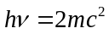
from conservation of momentum 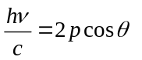 or, 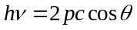 or, 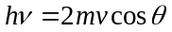
or, 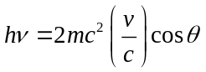 Since, 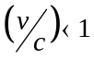; cosθ ≤ 1 so, 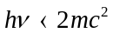
But conservation of energy requires that hν = 2mC². Hence it is impossible for pair production to conserve both energy and momentum unless some other object is involved in the process to carry away part of the initial photon momentum.

Assignment PROBLEM

- Prove that it is impossible for a photon to give up all its energy and momentum to a free electron, so that photoelectric effect can take place only when photons strikes bound electrons.
- A beam of X-rays is scattered by free electrons. At 45° from the beam direction the scattered X rays have a wavelength of 0.022 Å. What is the wavelength of the X rays in the direct beam? [Ans: 0.015Å]
- An X rays photon whose initial frequency was 1.5 ×10¹⁹ sec⁻¹ emerges from a collision with an electron with a frequency of 1.2 ×10¹⁹ sec⁻¹. How much kinetic was imparted to the electron? [Ans: 12.43KeV]
- An x rays photon of initial frequency 3 ×10¹⁹ sec⁻¹ collides with an electron and is scattered through 90°. Find its new frequency. [Ans: 2.42×10¹⁹sec⁻¹]
- Find the energy of an X- ray photon which can impart a maximum energy of 50 KeV to an electron.
[Ans: 0.141MeV]
- A monochromatic X-ray beam whose wavelength is 0.558Å is scattered through 46°. Find the wavelength of the scattered beam. [Ans: 0.565Å]
- A 1,000 Watt radio transmitter operates at a frequency of 880 KHz. How many photons per second does it emit? [Ans: 1.71×10³⁰ photons/sec]
- Light from the sun arrives at the earth, an average of 1.5×10¹¹ m away, at the rate of about 1,400 watts/m² of area perpendicular to the direction of the light. Assume that sunlight is monochromatic with a frequency of 5.0×10¹⁴ Hz. (a) how many photons fall per second on each square meter of the earth’s surface directly facing the sun? (b) What is the power output of the sun in watts, and how many photons per second does it emits? (c) How many photons per m³ are there near the earth?
[Ans: 4.2×10²¹photons/m²; 4.0×10²⁶W,1.2×10⁴⁵photons/s; 5.6×10¹³ photons/m³]
- Consider an X-ray beam, with λ=1.00Å, and also a γ-ray beam from a Cs¹³⁷ sample, with λ=1.88×10⁻² Å. If the radiation scattered from free electrons is viewed at 90° to the incident beam (a) what is the Compton wavelength shift in each case? (b) What kinetic energy is given to a recoiling electron in each case? (c) What percentage of the incident photon energy is lost in the collision in each case?
[Ans: 0.0242Å in each case, 0.295KeV & 378KeV, 2.4% & 57%]
- Show that maximum kinetic energy of recoiling electron is , where m₀, rest mass of electron, λ, wave length of the incident X ray beam and λ_{C}, the Compton wavelength.
- Show that , the fractional change in photon energy in the Compton effect, equal (hν’/m₀C²)(1-cosθ).
- What fractional increase in wavelength leads a 75% loss of photon energy in a Compton collision?
[Ans: 300%]
- Through what angle must a 0.20 MeV photon be scattered by a free electron so that it loses 10% of its energy? [Ans : 44.19°]
- What is the maximum possible kinetic energy of a recoiling Compton electron in terms of the incident photon energy hν and the electron’s rest mass energy m₀C²?
- A particular pair is produced such that the positron is at rest and the electron has a kinetic energy of 1.0 MeV moving in the direction of flight of the pair-producing photon. (a) Neglecting the energy transferred to the nucleus of the nearby atom, find the energy of the incident photon. (b) What percentage of the photon’s momentum is transferred to the nucleus? [Ans: 2.02 MeV, 29.7%]
- Assume that an electron-positron pair is formed by a photon having the threshold energy for the process. (a) Calculate the momentum transferred to the nucleus in the process. (b) Assume the nucleus to be that of a lead atom and compute the kinetic energy of the recoil nucleus. Are we justified in neglecting this energy compared to the threshold energy assumed above? [Ans: 5.44×10⁻²² kg-m/Sec, 2.71 eV, yes ]

PART THREE

§ 1. Wave Particle Duality
The phenomenon like interference, and diffraction and polarization can only be explained only by treating light as a wave whereas the phenomenon like photoelectric effect Compton effect and pair production its particle nature. Therefore, it is worth while to assume that light behaves like wave and particle both depending on the situation. This termed as dual nature of light.
These two different natures are not found simultaneously.

According to Planck's quantum theory of radiation, energy of photon can be represented as
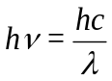 …(1)
According to energy momentum relation for a photon 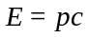 ( as photon has zero rest mass) …(2)
From relation (1) and (2) we get, 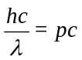 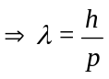
The above expression represents the relation of the particle (p) and wave () nature of a photon.

Louis de-Broglie in 1924 extended the wave particle dualism of radiation to all physical particles.
According to him, this wave-particle duality is not only valid for photon particle, it is also valid for any moving particle. “ a moving particle behaves in certain ways as though it has a wave nature”. A wave is associated with a moving particle.

§ 2. de-Broglie hypothesis
According to de-Broglie hypothesis, the motion of a particle is compared by a wave and the wave which is associated with moving particle is called de-Broglie wave or matter wave.
The wavelength of matter wave is given by 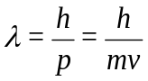
where h -- planck's constant.
p -- momentum of particle of mass `m' and velocity v.

§ 2.1 de-Broglie wavelength interms of kinetic energy

§ 2.1.1 de-Broglie wavelength for non relativistic case

The de-Broglie wavelength associated with material particle of mass `m' and moving with velocity `v' is given by 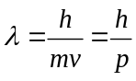
Now kinetic energy of particle 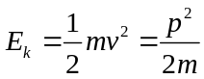 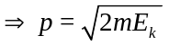 or, 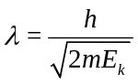
§ 2.1.2 de-Broglie wavelength for relativistic case
Using the energy momentum relation we have 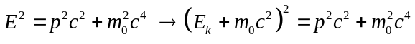
Or, 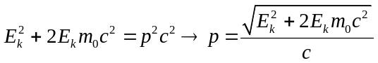
Again from the , putting the value of 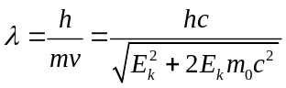
§ 2.2 de-Broglie wavelength associated with charged particle
Let m be the mass of particle, `q' be the charge on the particle which is accelerated through `V' v / m. Then, gain in kinetic energy =Loss is potential energy 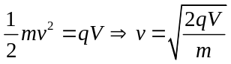
According to de-Broglie hypothesis, 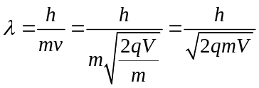
As we know 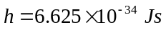 and for electron , 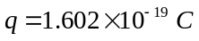 and 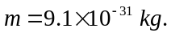 Substituting these value we get, de-Broglie wavelength associated with electron accelerated through `V' volts is given by 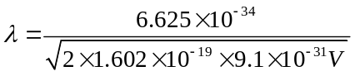
So, 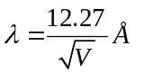

§ 3 Difference between E.M Wave and matter wave

- Matter waves are produced whether the particle is charged or uncharged one. But electromagnetic waves are produced by the motion of charged particles.

§ 4 de-Broglie hypothesis regarding wave nature of matter leads to Bohr’s quantisation for angular momentum
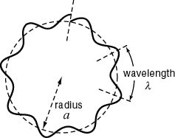
According to Bohr's atomic model, electron revolves round the nucleus in different orbits and only those orbits are possible for which the orbital angular momentum of the electron is equal to an integral multiple of 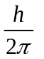 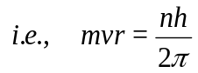
where , h Planck's constant. 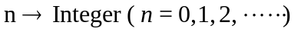
On the basis of de-Broglie hypothesis, he proposed an atomic model in which the stationary orbits of the Bohr's model are retained, but he assumed that the electrons in various orbits behaves like wave.
According to him, stationary orbits are those in which orbital circumference is an integral multiple of de-Broglie wavelength and stationary orbits for an electron are those which contain the complete waves of electron. Thus 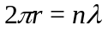
or,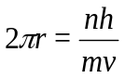 or 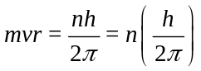 where , 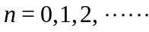
Which Bohr's quantization condition.

§ 5. Experimental verification of matter wave { Not for Exam}
Davisson-Germer and G.P Thomson' Experiment
Davisson and Germer gave the experiment, which proves the validity of de-Broglie hypothesis regarding the wave nature of matter, in 1927. They succeeded in measuring the de-Broglie wavelength associated with slow electrons.
Davisson and Germer were studying the reflection of electrons from nickel & tungsten. They found that the reflection shows striking maxima and minima.

Experimental Arrangement
Experimental arrangement used by Davisson and Germer is as shown in fig. below. G is the electron gun in which electrons are produced and obtained in a fine beam. Electron gun consists of tungsten filament F, where electrons are emitted due to thermionic emission.
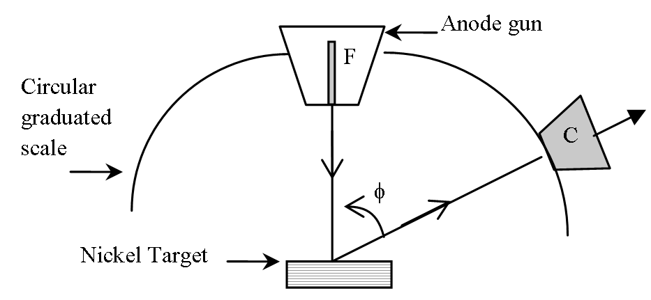
The anode in the gun accelerates these electrons. This accelerated and collimated beam of electrons is then allowed to fall on nickel target.

These electrons acting like waves are diffracted in different directions. The angular distribution is then
Figure 2:

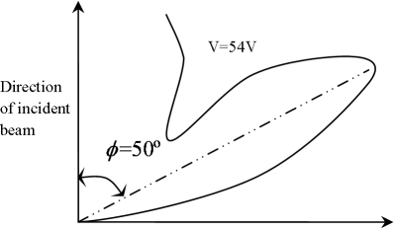
measured by the electron detector C. `C' can be rotated on circular graduated scale between 20 to 90 to receive the reflected electrons.
For a given value of accelerating voltage,the intensity is plotted against . The scattering curve shows a peak in a particular direction, C for given value of potential difference. It is observed that the intensity of the scattered beam is

maximum at 50 when the accelerating voltage is 54 volts. The results of the experiment are represented in the form of a polar graph as shown above. Theoretical value of 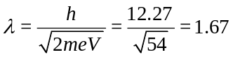Å
Evidently the angle of incidence relative to the crystal plane is 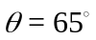. From X-rays measurements the inter planar distance for Ni crystal is found to be 0.909 Å i.e., d value.
Using Bragg's equation 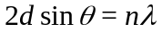
i.e., 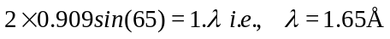
The experimental observed results are explained considering that electrons are diffracted by nickel crystal. Diffraction is the phenomenon which can be explained on the basis of wave nature. Thus this experiment gives experimental proof of de-Broglie hypothesis.

- Nature of the wave associated with the moving particle

According to de-Broglie, a wave is associated with a moving particle and we consider a single wave is associated with a moving particle. So we will check whether the velocity of the single wave train is equal to the particle velocity or not?

6.1 Phase velocity
Let a plane harmonic wave of frequency ν and wavelength λ travelling in positive x-direction is represented as 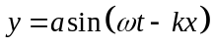, the speed of propagation of this wave will be the speed associated with a point for which phase 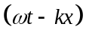 remains constant i.e = constant
or, 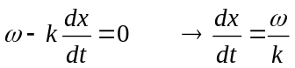 or, 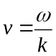. We define this velocity as 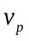, the phase velocity of the single wave train.
The phase velocity of a monochromatic wave is the velocity with which a crest or trough is propagated in a medium keeping the phase constant. So, 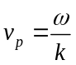We further know that
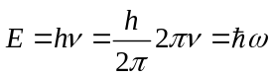 and 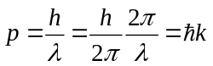 [ 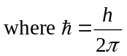]
- For non-relativistic case:
From the expression of phase velocity we have 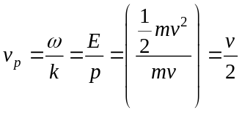 where v is the particle velocity.
- For relativistic case:

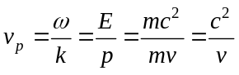

In both non relativistic and relativistic cases we see, phase velocity ≠particle velocity.
So it is justified that a single wave is not associated with a moving particle.

Justification of non existence of single wave associated with a moving particle:

A single wave has infinite extent in space. It has non-zero amplitude over a region of infinite dimension in space. But a material particle can be localized, it must be found within a region of finite dimension in space. So it would have no physical meaning to associate a single wave with a moving particle.

6.2 Group velocity

Now instead of a single wave train we consider a group of waves or wave packet is associated with a moving particle. Similarly we will check the validity of this velocity of this packet of wave associated with a moving particle.

Let us consider two waves of same amplitude, but of slightly different frequencies superpose to form a wave packet.
Let us consider two such waves are represented as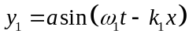 and 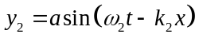
The resultant displacement of the wave packet obtained due to their superposition

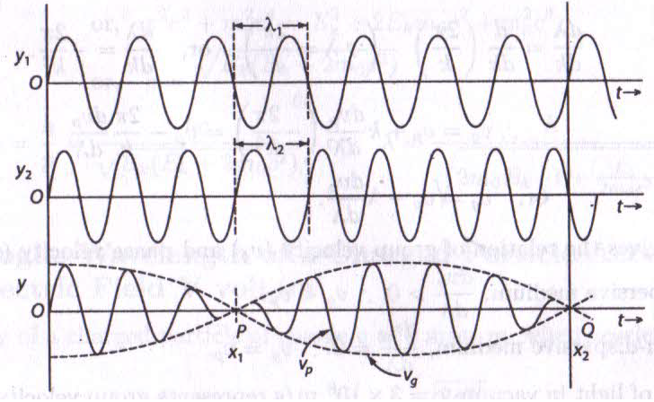

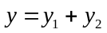 or, 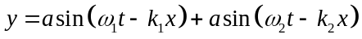
Or, 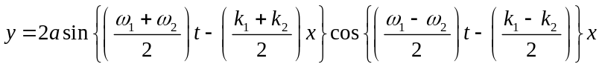
Or, 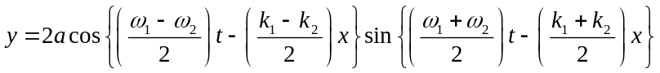
Or, 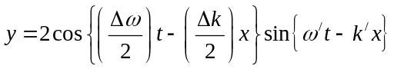
Where 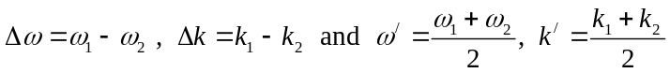
So the amplitude of the resultant wave packet will be 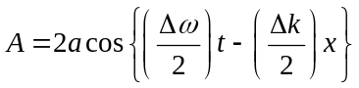
The resultant wave have angular frequency 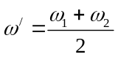 and wave vector 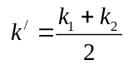 and it’s amplitude varies with cosine term having angular frequency 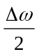 and wave vector 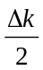.The velocity of the envelope or the modulated wave can be written as
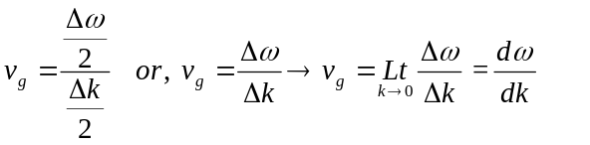
We define this velocity as 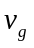, the group velocity of the wave packet So 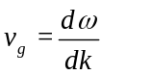
The group velocity is the velocity with which the envelope of the modulated pattern travels in a medium.

Now we will check the validity of the group of waves associated with a moving particle

- For non-relativistic case:
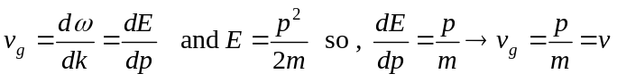
So we get 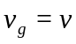 i.e., the particle velocity is equal to the group velocity in non-relativistic particle.

- For relativistic case:
Here 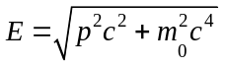 so 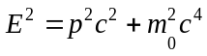 or, 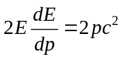
or, 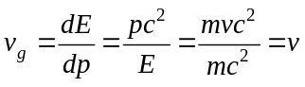
Again, the group velocity is equal to the particle velocity in relativistic particle.
Moreove the wave packet has non zero amplitude in finite dimension in space and the particle must be present in this region. So the concept of wave packet corresponding to particle velocity is justified.

Note:
If the number of superposed waves is increased, the regions with prominent humps will be narrower while the intervening regions of weaker disturbances will become broader. In the limit, if an infinite number of waves of continuously varying frequencies extending over a finite range is superposed we get a single hump within a narrow region with no disturbances at any other point. This is known as wave packet.
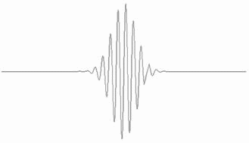

6.2.1 Relation between Group velocity and Phase Velocity

Group velocity of the wave packet is given by 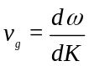
From the relation, 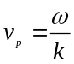 we have 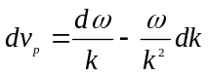
or, 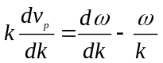 or, 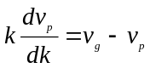
or, and as 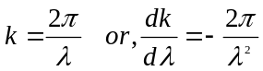
Hence 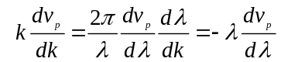
So,

§ 8 Heisenberg’s Uncertainty Relation

- Position and momentum uncertainty
In reference to the figure of article 6.2 we can write 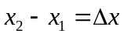. From the figure it is evident that
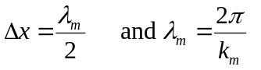
where . Again from the expression of the amplitude of the modulated wave i.e, we have 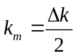 . So 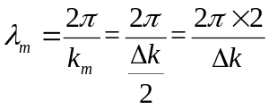 . Putting the value of 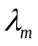in 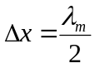 we have 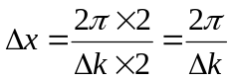 …………………(1)
From 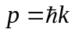we have 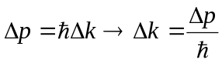. Putting this 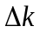 in equation (1) we have 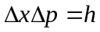
But wave packet consists of large number of single wave . Using fourier transform considering these large number of waves it can be shown that 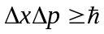
Statement of uncertainty: It is impossible to specify accurately and simultaneously the measurement of both momentum and posion of a moving quantum particle. The product of their ( positon and momentum) uncertainty is equal to or greater than. Mathematically

- Energy and time uncertainty
For simultaneous measurement of energy and time we can write
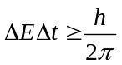
where E and t uncertainties in energy and time respectively.

§ 8.1 Significance of Heisenberg’s uncertainty principle
- Simultaneous determination of conjugate properties like x and p or E and t, with unlimited accuracy is impossible.
- Dual nature of wave and particle is inherent like two faces of coin. Hence we can examine one aspect accurately at a time, either wave or particle nature but not both at the same time.

§ 9 Application of Heisenberg’s uncertainty principle

Example 1:
By applying uncertainty principle explain non-existence of electrons in the atomic nucleus.
Answer:
We know Max K.E of an electron (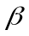 - particle) emitted by a radioactive nuclei 4 MeV
(rest mass of the electron)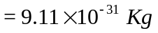
2r (diameter of nucleus) 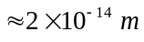 or, 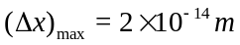
From 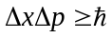 or, 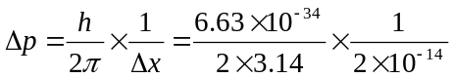
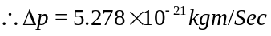
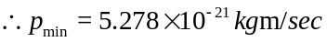
Now
Now 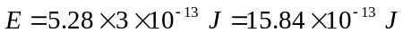
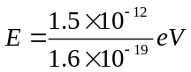 Hence 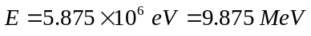
Thus, if a free electron exists in the nucleus, it must have energy of the order of 9.0 MeV.
But the maximum Kinetic energy of a -particle ( equivalent electron emitted from a radioactive nuclei ) is 4 MeV which is much less than theoretical value ( discussed above). So a free electron can not be present inside the nucleus.

Example 2
Assume that an electron is inside a nucleus of radius 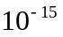m. Calculate from the uncertainty principle the minimum kinetic energy of the electron.[Given, 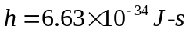.Electron mass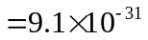kg].
Answer:
According to Heisenberg’s uncertainty principle we can write 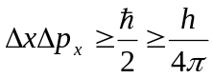; 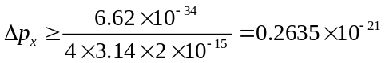 Kg mS⁻¹
Kinetic Energy = 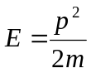 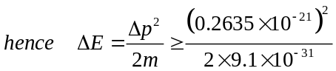
Or, 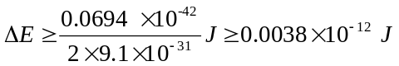
Or,

Example 4:
What is the uncertainty in momentum of a proton when it is inside the nucleus? Is it consistent with binding energy of nuclear constituent?
Answer:
If a proton is inside the nucleus the uncertainty in momentum will be 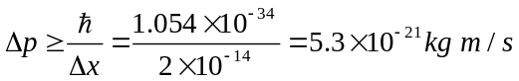
The corresponding kinetic energy 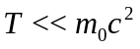
Hence 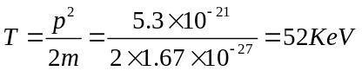
The binding energy of the nuclei (proton-neutron) are of this order. So it is verified.

Assignment PROBLEM

- An electron and a photon each have a wavelength of 2.0Å. What are their (a) momenta (b) total energies? (c) Compare the kinetic energies of the electron and the photon.
[3.31×10⁻²⁴ kg m/s, E_{e} =510037.62 eV and E_{photon} =6200eV, (E_{K})_{electron}=37.62 eV and (E_{K})_{photon}=6200 eV]

- A non relativistic particle is moving three times as fast as an electron. The ratio of their de Broglie wavelengths, particle to electron is 1.1813×10⁻⁴. Identify the particle. [Neutron]

- (a) Show that the de-Broglie wavelength of a particle, of charge ‘e’ rest mass m₀, moving at relativistic speeds is given as a function of the accelerating potential V as
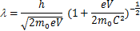
- Find the kinetic energy of an electron whose de-Broglie wavelength is the same as that of a 100-KeV X-ray. [9.74 KeV]
- An electron and a proton have the same kinetic energy. Compare the wavelengths and the phase and group velocities of their de-Broglie waves. [λ_{e}>λ_{p}, both the particle have the same phase & group velocity]
- An electron and a proton have the same velocity. Compare the wavelengths and the phase and group velocities of their de-Broglie waves. [λ_{e}>λ_{p}, both the particle have the same phase & group velocity]
- An electron and a proton have the same wavelength. Prove that the energy of the electron is greater.
- Calculate de-Broglie wavelength of a neutron or an electron of energy 1MeV. Compare it with the wavelength of electromagnetic radiation for which the photon has the same energy.
[λ_{n}=2.87×10⁻¹⁴m, λ_{e}=10.11×10⁻¹³m, λ_{photon}=12.43×10⁻¹³m]
- Show that if a particle moves with velocity 0.707C where C is the velocity of light in vacuum, then its de-Broglie wavelength and Compton wavelength become equal. [0.707C=C/√2]
- The phase velocity of ripples on a liquid surface is 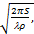 where S is the surface tension and the density of the liquid. Find the group velocity of the ripples. [v_{g} =(3/2)v_{p}]
- The phase velocity of ocean waves is, where g is the acceleration of gravity. Find the group velocity of ocean waves. [v_{g}= ½ v_{p}]
- Find the phase and group velocities of the de-Broglie waves of an electron whose speed is 0.900C.
- Show that the group velocity of a wave is given by
- A) show that the phase velocity of the de-Broglie waves of a particle of mass m and de-Broglie wavelength λ is given by
b) Compare the phase and group velocities of an electron whose de Broglie wavelength is exactly 1×10⁻¹³m. [v_{p} = 1.01C, v_{g} = 0.99C]
14. An electron of mass 9.1×10⁻³¹ kg has a speed of 1km/sec with an accuracy of 0.05%. Calculate the uncertainty with which the position of the electron can be located. [0.232×10⁻³m]

15. An electron is confined to a box of length 10⁻⁹ m. Calculate the minimum uncertainty in its velocity. [0.116×10⁶ m/s]
16. The life time of an excited state of an atom is 10⁻⁸ sec. Calculate the minimum uncertainty in the determination of energy of the excited state. [6.25×10⁻⁸ eV]

17. Show that if the uncertainty in the location of a particle is about equal to its de Broglie wavelength, than the uncertainty in its velocity is about equal to one sixth its velocity?

18. The speed of a bullet of mass 50 gm is measured to be 300 m/s with an uncertainty of 0.01%. With what accuracy can we locate the position of the bullet if it is measured simultaneously with its speed?
[7.07×10⁻³²m]
19. The angular momentum of the electron in the hydrogen atom is 2ħ with an error of 5 %. Show that its angular position in a circular orbit around the nucleus cannot be specified at all.

